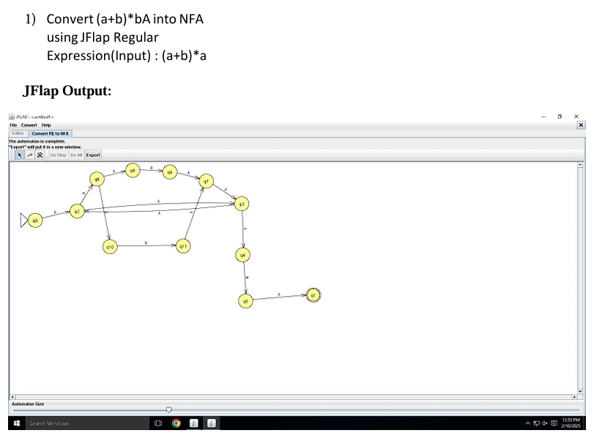

Algorithm for Converting Regular Expression (A+B)\* to NFA

1. Define State Structure:

Each state has a unique ID and transition mappings.

2.

Define NFA Structure:

Contains a start state, final states, and a set of states.

3.

Create Basic NFA for a Character (basicNFA(char c))

Create two states, add a transition on c, set start and final states.

4.

Create Union NFA (unionNFA(NFA a, NFA b))

Create a new start state with ε-transitions to both NFAs, merge states.

5.

Apply Kleene Star (kleeneStar(NFA a))

Add new start and final states, loop back using ε-transitions.

6.

Construct Final NFA in main()

Build NFAs for A and B, compute union, apply Kleene Star, print confirmation.

